TP1:

* -cara-simulator is an open source simulator
* We´re using V9.8 in Verbindung mit carla-ros-bridge, ROS mit python3 packages
* Testscenario in Python3.5 Implementiert
* Als Basis dient das NCAP P-AEB Test Scenario Perpendicular child (CPNC-50) vom IIHS (Insurance Institute for Highway Safety) Pedestrian Autonomous Emergency Braking Test Protocol (Version II) stand Februar 2019

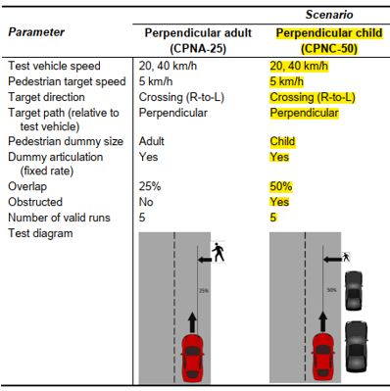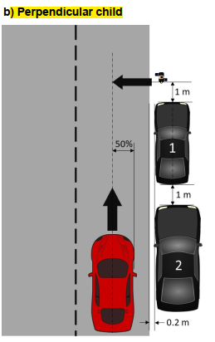

* Testing conditions:
  + running speed for the perpendicular child 5 +- 0.2 km/h
  + Target Placement: Child pedestrian target is positioned 4 m laterally from the center of the ego vehicle behind two parked cars. The target is crossing the lane from right-to-left, such that the ego vehicle approches the left side oft he target. The hit-point without an emergency stop of the ego vehicle would be the vertical centerline of the car (50% Overlap).
  + A small car (1) and a SUV (2) obstruct the visibility of the perpendicular child.
  + In this case the small car is realized as an Audi TT and the SUV as an Audi E-Tron.
  + The left edges of both cars are parked 0.2m away from the right edge of the test lane
  + The logitudinal difference betwen the two vehicles and as well the pedestrian is 1 m
  + the ego vehicle is centered in the lane and begins moving 200 m away from the pedestrian and quickly accelerats to 40 km/h.
* Changed Testing conditions:
  + The placement of the perpendicular child wurde X m nach rechts versetzt. Verändert um zu testen ob das Messsystem das Kind bereits aus großer Entfernung erkennen kann. Nachfragen!
* Programmed Scenario:
  + After launching carla and the scenario script the 3 vehicles and the pedestrian will be spawned into the scenario
  + the ego vehicle is centerd in his lane 200m behind the pedestrian target
  + after a few seconds the ego vehicle starts quickly accelerating to 40 km/h
  + a few seconds later the child starts his moving with 5 km/h from right-to-left to cross the street
  + from now on the child is constantly holding his speed until he completely crossed the street
  + the child becomes visible for the ego vehicle about 5m behind the parked SUV
  + about 0.5 s later the ego vehicle initiates an emergency stop and comes to a standstill in front of the pedestrian child. At this point the pedestrian is at the 50% overlaping point of the car.
  + The scenario will end as soon as the child completely passed by the ego vehicle
* Ground Thruth Data:
  + Generating 2 topics an publish them via ros
  + Topic 1 includes a header with timestamp and Object ID and as well an ObjectsList message which includes the Classification, Dimension, Features and Geomitc of the pedestrian and both parked cars. The coordinates refer to the center of the objects
  + Topic 2 includes also a header with timestamp and Object ID but in this case only the ObjectList message with the Geometric data of the ego vehicle. The camera position is at the front middle of the car, so the coordinates refer to this point
  + 2 options by launching the scenario
    - 1.) publishing in topic 1 only Objects which are in the field of view of the camera; 200m and total opening angle 60°
    - 2.) publishing in topic 1 always all grout truth data of the 3 spawned objects

Generating GT Data: